**Bad design**

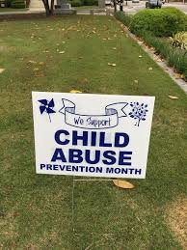

**Reasons why it’s a bad design**

* It has a contradictory message- the message portrayed is unclear we are not sure if it’s actually supporting the child abuse month or its supporting child abuse
* There’s lack of clarity- the we support caption isn’t clear its in small fonts so the eye can’t really capture it
* Lack of prioritization of words-instead of the words we support and prevention month be bold and large fonts, the child abuse is the one being seen by the eyes first and this can send the wrong message.

**Good design**



**Reasons for the good design**

* There’s integration of colors which makes it attractive to the eye and makes one to be able to differentiate between the colors.
* The shapes are uniquely definite to each other-one can differentiate between one shape and the other.
* The shapes are big and clear and doesn’t need one to strain to look at them and they are spaced evenly.